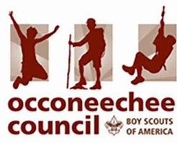
GAPS ACCESSIBLE UNIT APPLICATION
As a GAPS designated Accessible Unit, we recognize that trained volunteer leaders are enthusiastic about supporting scouts with disAbilities. We understand our Unit may face unique challenges and demands yet promise to remain compassionate in supporting both accommodations for rank advancement, and towards building self-esteem and feelings of accomplishment to enable successful outcomes for everyone involved in our program.
We can support Scouts with all abilities and their families by:
• Providing an inclusive and understanding atmosphere together in Scouting.
• Helping and assisting each Scout family attain (reach) their goals in scouting.
• Providing an opportunity for the Scout to advance through the program.
• Raising abilities awareness in all youth, adults, and our community.
Roles and Responsibilities of Accessible Units:
- Committee Chair / Unit Leader (CM, SM, CA) make a commitment to welcome and work with Scouts of all abilities.
- Conduct an annual Facilities Checklist and discuss results at the unit leader meeting.
- Have a safe area for Scouts with sensory challenges to go to when they feel overwhelmed.
- Conduct an annual Abilities Awareness Night for youth in the unit.
- Fill out and update the annual special needs survey.
- Commitment to at least one abilities awareness presentation for leaders and parents per year.
Unit Rep Signature: _____________________________________________ Date: _________________
Unit #: ______________ District: _________________ Email: _________________________________
Council or District Special Needs Representative: _____________________________________________
Date Approved: ___________________
Return to: occoneecheeGAPS@gmail.com

